Parcel 71

315 Genesee St, City of Olean

|  |  |  |  |  |  |  |  |  |
| --- | --- | --- | --- | --- | --- | --- | --- | --- |
| http://maps.cattco.org/imate/quickstream.aspx?file=VOLLOCAL/Rel2017/041200094042000406100000000005.jpg&thumb=true&width=201&height=152 | | | | **Status:** | | Active | | |
| **Roll Section:** | | Taxable | | |
| **Swis:** | | 041200 | | |
| **Tax Map ID #:** | | 94.042-4-61 | | |
| **Property Class:** | | 210 - 1 Family Res | | |
| **Site:** | | RES 1 | | |
| **In Ag. District:** | | No | | |
| **Site Property Class:** | | 210 - 1 Family Res | | |
| **Zoning Code:** | | - | | |
| **Neighborhood Code:** | | 12208 | | |
| **Total Acreage/Size:** | | 50 x 150 | | **School District:** | | Olean | | |
| **Land Assessment:** | | 2017 - $13,800 | | **Total Assessment:** | | 2017 - $35,000 | | |
| **Full Market Value:** | | 2017 - $39,326 | |  | |  | | |
| **Living Area:** | | 1,280 sq. ft. | | **First Story Area:** | | | 640 sq. ft. | |
| **Second Story Area:** | | 640 sq. ft. | | **Half Story Area:** | | | 0 sq. ft. | |
| **Finished Basement:** | | 0 sq. ft. | | **Number of Stories:** | | | 2 | |
| **Building Style:** | | Old style | | **Bathrooms (Full - Half):** | | | 1 - 1 | |
| **Bedrooms:** | | 3 | | **Kitchens:** | | | 1 | |
| **Fireplaces:** | | 0 | | **Basement Type:** | | | Full | |
| **Porch Type:** | | Porch-covered | | **Porch Area:** | | | 160.00 | |
| **Overall Condition:** | | Fair | | **Overall Grade:** | | | Average | |
| **Year Built:** | | 1928 | |  | |  | | |
| **Structure** | **Size** | | **Grade** | | **Condition** | | **Year** |
| Porch-covered | 10 × 16 | | Average | | Fair | | 1928 |
| Porch-up open | 10 × 16 | | Average | | Fair | | 1928 |
| Porch-covered | 5 × 10 | | Average | | Fair | | 1928 |
| Porch-covered | 4 × 5  MINIMUM BID $2500 | | Average | | Fair | | 0 |

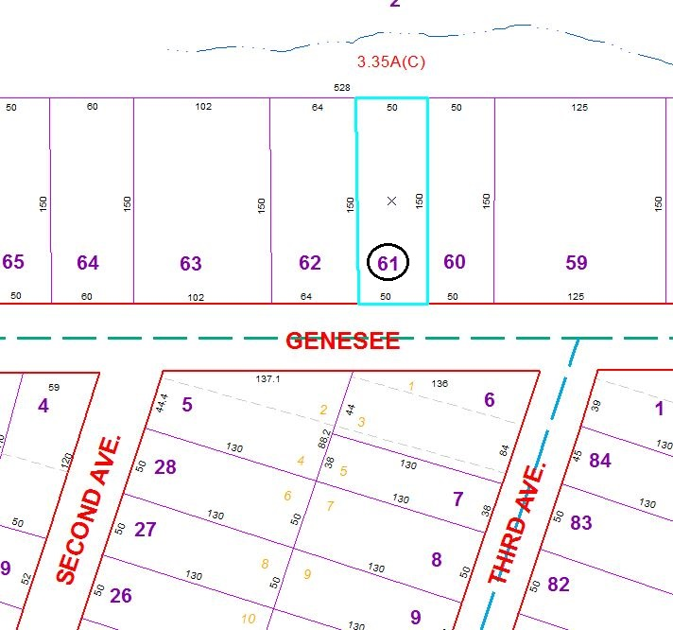

Approximate Yearly Taxes

School $914

City $510

County $490

Total $1,914

Special Districts for 2015