Parcel 51

141 Orleans Ave, City of Olean

|  |  |  |  |
| --- | --- | --- | --- |
| *No Photo Available* | | **Status:** | Active |
| **Roll Section:** | Taxable |
| **Swis:** | 041200 |
| **Tax Map ID #:** | 94.057-4-9 |
| **Property Class:** | 311 - Res vac land |
| **Site:** | RES 1 |
| **In Ag. District:** | No |
| **Site Property Class:** | 311 - Res vac land |
| **Zoning Code:** | - |
| **Neighborhood Code:** | 12205 |
| **Total Acreage/Size:** | 45.3 x 140 | **School District:** | Olean |
| **Land Assessment:** | 2017 - $1,000 | **Total Assessment:** | 2017 - $1,000 |
| **Full Market Value:**  LANDLOCKED, PARCEL IN PERMANENT EASEMENT ZONE FOR NYS FLOOD PROJECT | 2017 - $1,124  Approximate Yearly Taxes  School $26  City $15  County $14  Total $55 |  |  |

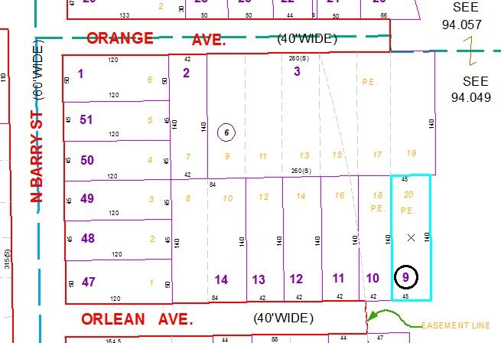

Special Districts for 2015