Parcel 313

Jackson Ave, Town of Olean

|  |  |  |  |  |
| --- | --- | --- | --- | --- |
| *No Photo Available* | | **Status:** | Active | |
| **Roll Section:** | Taxable | |
| **Swis:** | 046600 | |
| **Tax Map ID #:** | 94.076-1-45 | |
| **Property Class:** | 314 - Rural vac<10 | |
| **Site:** | RES 1 | |
| **In Ag. District:** | No | |
| **Site Property Class:** | 314 - Rural vac<10 | |
| **Zoning Code:** | - | |
| **Neighborhood Code:** | 66370 | |
| **Total Acreage/Size:** | 3.82 | **School District:** | Olean | |
| **Land Assessment:** | 2017 - $14,200 | **Total Assessment:** | 2017 - $14,200 | |
| **Full Market Value:** | 2017 - $18,442 |  |  |

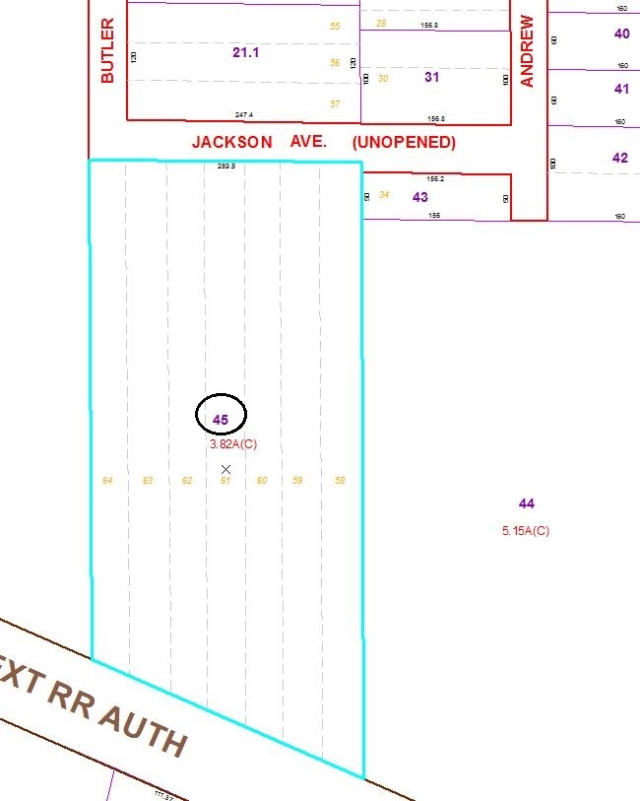

Approximate Yearly Taxes

School $438

Town/County $330

Total $768

Special Districts for 2015