Parcel 273

46 Sunset Dr., Town of Machias

|  |  |  |  |  |  |  |  |  |  |
| --- | --- | --- | --- | --- | --- | --- | --- | --- | --- |
| http://maps.cattco.org/imate/quickstream.aspx?file=VOLLOCAL/Rel2017/045800021060000100400000000006.jpg&thumb=true&width=201&height=152 | | | | **Status:** | | | Active | | |
| **Roll Section:** | | | Taxable | | |
| **Swis:** | | | 045800 | | |
| **Tax Map ID #:** | | | 21.060-1-4 | | |
| **Property Class:** | | | 271 – Mfg. housings | | |
| **Site:** | | | RES 1 | | |
| **In Ag. District:** | | | No | | |
| **Site Property Class:** | | | 271 – Mfg. housings | | |
| **Zoning Code:** | | | 01 | | |
| **Neighborhood Code:** | | | 58050 | | |
| **Total Acreage/Size:** | | 285 x 200 | | **School District:** | | | Yorkshire-Pioneer | |
| **Land Assessment:** | | 2017 - $11,300 | | **Total Assessment:** | | | 2017 - $48,100 | |
| **Full Market Value:** | | 2017 - $49,082 | |  | | |  | |
| **Porch Type:** | | Porch-enclosed | | **Porch Area:** | | | 160.00 | |
| **Structure** | **Size** | | **Grade** | | **Condition** | **Year** | |
| Shed-machine | 8 × 8 | | Economy | | Fair | 1970 | |
| Shed-machine | 8 × 10 | | Economy | | Fair | 2000 | |
| Shed-machine | 4 × 6 | | Economy | | Fair | 2000 | |
| Mh:tip-out | 4 × 6 | | Economy | | Fair | 1970 | |
| Mobile home | 60 x 12 | | Economy | | Fair | 1970 | |
| Porch-enclosed | 20 x 8 | | Economy | | Fair | 1970 | |
| Porch-enclosed | 0 x 0 | | Economy | | Fair | 1980 | |

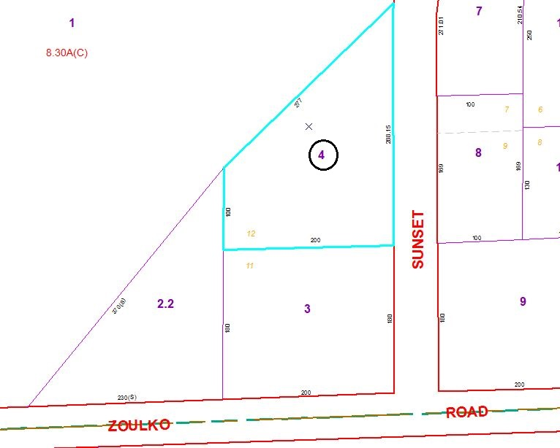

Approximate Yearly Taxes

School $649

Town/County $903

Total $1,552

Special Districts for 2015