Parcel 243

 Johnson Hollow Rd, Town of Ischua

|  |  |  |  |
| --- | --- | --- | --- |
| *No Photo Available* | | **Status:** | Active |
| **Roll Section:** | Taxable |
| **Swis:** | 045000 |
| **Tax Map ID #:** | 68.003-1-14.3 |
| **Property Class:** | 314 - Rural vac<10 |
| **Site:** | RES 1 |
| **In Ag. District:** | No |
| **Site Property Class:** | 314 - Rural vac<10 |
| **Zoning Code:** | 01 |
| **Neighborhood Code:** | 50050 - Town |
| **Total Acreage/Size:** | 3.20 | **School District:** | Hinsdale |
| **Land Assessment:** | 2017 - $6,800 | **Total Assessment:** | 2017 - $6,800 |
| **Full Market Value:** | 2017 - $7,727  Approximate Yearly Taxes  School $69  Town/County $150  Total $219 |  |  |

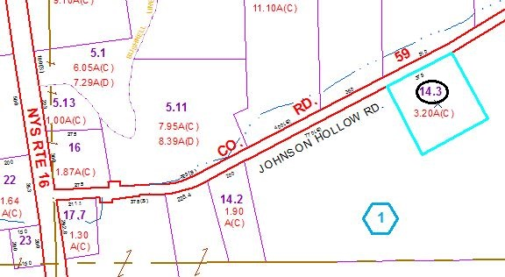

Special Districts for 2015