Parcel 206

12 Riggs St, Village of Franklinville

|  |  |  |  |  |  |  |  |  |  |
| --- | --- | --- | --- | --- | --- | --- | --- | --- | --- |
| *See county website*  *For photo* | | | | **Status:** | | Active | | | |
| **Roll Section:** | | Taxable | | | |
| **Swis:** | | 044001 | | | |
| **Tax Map ID #:** | | 40.062-4-3.3 | | | |
| **Property Class:** | | 210 - 1 Family Res | | | |
| **Site:** | | RES 1 | | | |
| **In Ag. District:** | | No | | | |
| **Site Property Class:** | | 210 - 1 Family Res | | | |
| **Zoning Code:** | | - | | | |
| **Neighborhood Code:** | | 40150 | | | |
| **Total Acreage/Size:** | | 60.4 x 120.2 | | **School District:** | | Franklinville | | | |
| **Land Assessment:** | | 2017 - $6,000 | | **Total Assessment:** | | 2017 - $35,000 | | | |
| **Full Market Value:** | | 2017 - $52,239 | |  | |  | | | |
| **Living Area:** | | 1,684 sq. ft. | | **First Story Area:** | | | | 1,156 sq. ft. | | |
| **Second Story Area:** | | 528 sq. ft. | | **Half Story Area:** | | | | 0 sq. ft. | | |
| **Finished Basement:** | | 0 sq. ft. | | **Number of Stories:** | | | | 2 | | |
| **Building Style:** | | Old style | | **Bathrooms (Full - Half):** | | | | 2 - 0 | | |
| **Bedrooms:** | | 3 | | **Kitchens:** | | | | 1 | | |
| **Fireplaces:** | | 0 | | **Basement Type:** | | | | Partial | | |
| **Porch Type:** | | Porch-open/deck | | **Porch Area:** | | | | 200.00 | | |
| **Overall Condition:** | | Normal | | **Overall Grade:** | | | | Average | | |
| **Year Built:** | | 1930 | |  | |  | | | |
| **Structure** | **Size** | | **Grade** | | **Condition** | | **Year** | |
| Porch-open/deck | 20 × 10 | | Average | | Normal | | 1980 | |
| Porch-covered | 14 × 8 | | Average | | Normal | | 1960 | |

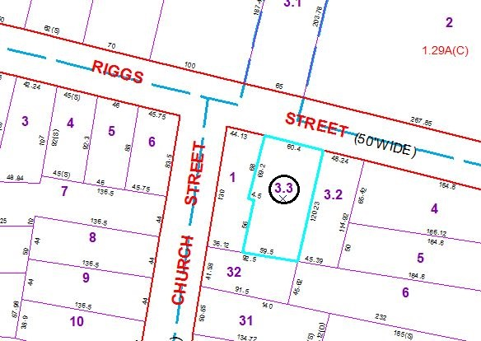

Approximate Yearly Taxes

School $921

Village $453

Town/County $1,028

Total $2,402

Special Districts for 2015