Parcel 111

  5498 Heinz Rd, Town of Ashford

|  |  |  |  |  |  |  |  |  |  |  |  |  |
| --- | --- | --- | --- | --- | --- | --- | --- | --- | --- | --- | --- | --- |
| http://maps.cattco.org/imate/quickstream.aspx?file=VOLLOCAL/Rel2017/042200020001000100300400000012.jpg&thumb=true&width=201&height=152 | | | | | | **Status:** | | | | Active | | |
| **Roll Section:** | | | | Taxable | | |
| **Swis:** | | | | 042200 | | |
| **Tax Map ID #:** | | | | 20.001-1-3.4 | | |
| **Property Class:** | | | | 210 - 1 Family Res | | |
| **Site:** | | | | RES 1 | | |
| **In Ag. District:** | | | | No | | |
| **Site Property Class:** | | | | 210 - 1 Family Res | | |
| **Zoning Code:** | | | | - | | |
| **Neighborhood Code:** | | | | 22010 | | |
| **Total Acreage/Size:** | | | 4.00 | | | **School District:** | | | | West Valley | | |
| **Land Assessment:** | | | 2017 - $8,300 | | | **Total Assessment:** | | | | 2017 - $49,400 | | |
| **Full Market Value:** | | | 2017 - $91,481 | | |  | | | |  | | |
| **Living Area:** | | 1,542 sq. ft. | | | **First Story Area:** | | | | | 1,094 sq. ft. | |
| **Second Story Area:** | | 448 sq. ft. | | | **Half Story Area:** | | | | | 225 sq. ft. | |
| **Finished Basement:** | | 0 sq. ft. | | | **Number of Stories:** | | | | | 2 | |
| **Building Style:** | | Old style | | | **Bathrooms (Full - Half):** | | | | | 1 - 0 | |
| **Bedrooms:** | | 4 | | | **Kitchens:** | | | | | 1 | |
| **Fireplaces:** | | 0 | | | **Basement Type:** | | | | | Partial | |
| **Porch Type:** | | Porch-covered | | | **Porch Area:** | | | | | 312.00 | |
| **Overall Condition:** | | Fair | | | **Overall Grade:** | | | | | Average | |
| **Year Built:** | | 1900 | | |  | | |  | | | |
| **Structure** | **Size** | | | **Grade** | | | **Condition** | | **Year** | |
| Gar-1.0 detached | 24 × 50 | | | Average | | | Fair | | 2003 | |
| Porch-covered | 12 × 26 | | | Average | | | Normal | | 2003 | |
| Porch-enclosed | 8 × 25 | | | Average | | | Fair | | 1900 | |
| Porch-enclosed | 12 × 14  MINIMUM BID $25,000 | | | Average | | | Fair | | 1900  Approximate Yearly Taxes  School $1,793  Town/County $1,492  Total $3,285 | |

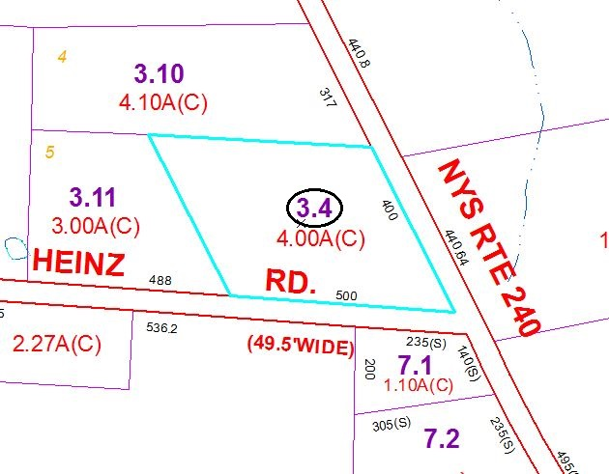

Special Districts for 2015